Anti-Accident System
أسماء التيم:
نهال عبد الحميد بدر أحمد (سكشن 7) نانسي يوسف يعقوب فهيم (سكشن 7)
ندي مرعي سيد صبره (سكشن 7) مورا منتصر خلف كامل ( سكشن 7)
منار اسحق كامل ملك (سكشن 7) هيلانه لمعي إسكندر شاروبيم ( سكشن 8)
EXCUTIVE SUMMARY:
The number of car accidents on the roads increased during 2019, and the number of deaths resulting from car accidents rose to 3,484 dead in 2019, an increase of 12.9%.
So we thought of making a system of machine learning that can be placed in cars, which partially calculates the distance and make sure that everything is alright and if it is not then it takes over the task of driving. It combines a variety of sensors to perceive their surroundings, such as radar, LIDAR, sonar, GPS, odometry and inertial measurement units. Advanced control systems interpret sensory information to identify appropriate navigation paths, as well as obstacles and relevant signage.
PRPJECT SCOPE:-
Objectives:
- Reducing accidents.
- Regulating traffic.
- Provide a safe journey for passengers and drivers.
- Contribute to the eradication of technology illiteracy.
- At the end of the project, a test of the project will be done on 100 cars to ensure the success of the project, and then it will be implemented in reality.
Deliverables:
  - Project plan.
  - Anti-accident system.
  - The device which will be put in the car.

Milestones:
  - In Feb 1st, we will start in our plan, the team and tasks will be divided, and the necessary information will be collected with project financiers and the device manufacturer, by Feb 8th our plan will be finished.
  - In Feb 8th we will bring sensors and we will finish by Mar 4th, and in the same time we will make self-driving system but it will be finished by Mar 20th.
  - In Mar 20th we will test the self-driving system and we will finish by Apr 5th.
  - In Mar 12nd we will make self-sensing system and it will be finished by Apr 19th.
  - In Apr 19th we will test the self-sensing system and we will finish by May 15th.
  - In Apr 13rd we will search for material for the camera and finish by Apr 29th.
  - In May 15th we will start making the full device and finish by Jun 15th, then we will perform tests on the full device and finish by Jul 8th.
  - Work may take place during weekends and holidays.
Technical Requirement:
  - Performance Availability: it will be available to all people.
  - Interoperability: the device will be permissible to all types of cars.
  - Maintainability: the device will have regular maintenance every four months.
  - Performance: the device will have the best performance.
Project Resources:
- Materials.
- Machine learning System expert.
Stakeholders:
- ORACLE: the Company which is responsible for the system.
- El-Garhy Steel: the Company which is responsible for the materials of the project.
- Essam Yousef: The sponsor of this project.
- Nehal: the leader of the team.
- Manar: The one who is responsible for managing the budget for the project.
- Nada: The one who makes the deals for the project.
- Mora: The one who is responsible of marketing.
- Nancy: The one who thinks in the team.
- Helana: The one who is responsible of the software
Communication Plan:
- An offline meeting every week.
- An online meeting every three days.

Budget:
- Materials
50,000$
- Programmers
10,000$ for each
- Marketing
26,000$
- Total cost
86,000$
- Emergency cost
15,000$

Gant Chart:

Responsibility Matrix:
TASKS | NEHAL | MANAR | NADA | MORA | NANCY | HELANA
Making Project Plan | R |  | R |  | R | R
Searching For Best Material For The Camera |  |  | R | S | S | R
Bringing Sensor | S | R | R | S | S | R
Making Self-Sensing System | R | R | S | S | R | S
Testing The Self-Sensing System |  |  | S | R
Making Self-Driving System | S | S | R | R | R | S
Testing The Self-Driving System | R | S
Making The Full Device | S | R |  | S | R | R
Perform Tests | R | S | S | R | S | R
WBS:

Network:
Activity | Description | Preceding Activity | Activity Time (Week)
A | Making Project Plan | None | 1
B | Searching For Best Material For The Camera | A | 2
C | Bringing Sensor | A | 3
D | Making Self-Sensing System | B,C | 6
E | Testing The Self-Sensing System | D | 2
F | Making Self-Driving System | A | 5
G | Testing The Self-Driving System | F | 2
H | Making The Full Device | E,G | 4
I | Perform Tests | H | 3

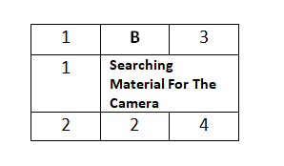
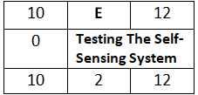
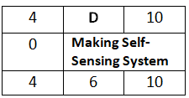

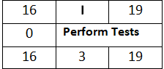
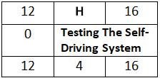
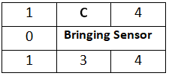
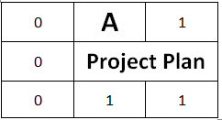

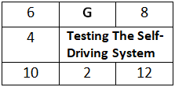
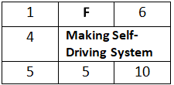

A, C, D, E, H, I

Time-Phased Budget:

Resource-Constrained Project:

Risks:
Technical Risk:
- We may have some missed requirements if one of the firms decided that it does not want to work with us anymore.
The Solution: we will make sure that there is another company would help us.

- We may lack in the performance of this invention.
The Solution: we will make sure that we hire the perfect team for this and have external people help us.

- The device might not work well and have some problems with it.
The Solution: we will make a check-up every four months.

External Risk:
Not all Egyptian will buy this device
The Solution: we will not let the car license (which happens every three years) be done unless you have the device installed in your car.

